**Sprint 4**

Web UI-

to make user interact with Software

|  |  |
| --- | --- |
| Date | 9 October 2022 |
| Team ID | PNT2022TMID05092 |
| Project Name | Project – Smart Farmer-IoT Enabled smart Farming Application |
| Maximum Marks | 4 Marks |

# Receiving commands from IBM cloud using Python program

import time import sys import ibmiotf.application import ibmiotf.device import random

#Provide your IBM Watson Device Credentials organization = "1xl08d" deviceType = "abcd" deviceId = "12" authMethod = "token" authToken = "12345678"

# Initialize GPIO

def myCommandCallback(cmd): print("Command received: %s" % cmd.data['command']) status=cmd.data['command'] if status=="lighton": print ("led is on") elif status==”lightoff”:

print ("led is off") else:

print(“please send proper command”)

#print(cmd) try:

deviceOptions = {"org": organization, "type": deviceType, "id": deviceId, "authmethod": authMethod, "auth-token": authToken} deviceCli = ibmiotf.device.Client(deviceOptions) #..............................................

except Exception as e:

print("Caught exception connecting device: %s" % str(e)) sys.exit()

# Connect and send a datapoint "hello" with value "world" into the cloud as an event of type "greeting" 10 times deviceCli.connect() while True:

#Get Sensor Data from DHT11 temp=random.randint(90,110)

Humid=random.randint(60,100) Mois=random.randint(20,100)

data = { 'temp' : temp, 'Humid': Humid ,’Mois’:Mois}

#print data def myOnPublishCallback():

print ("Published Temperature = %s C" % temp, "Humidity = %s %%" % Humid,

", Moisture = %s deg c" % Mois, to IBM Watson")

success = deviceCli.publishEvent("IoTSensor", "json", data, qos=0, on_publish=myOnPublishCallback)

if not success: print("Not connected to IoTF") time.sleep(1)

deviceCli.commandCallback = myCommandCallback

# Disconnect the device and application from the cloud deviceCli.disconnect()

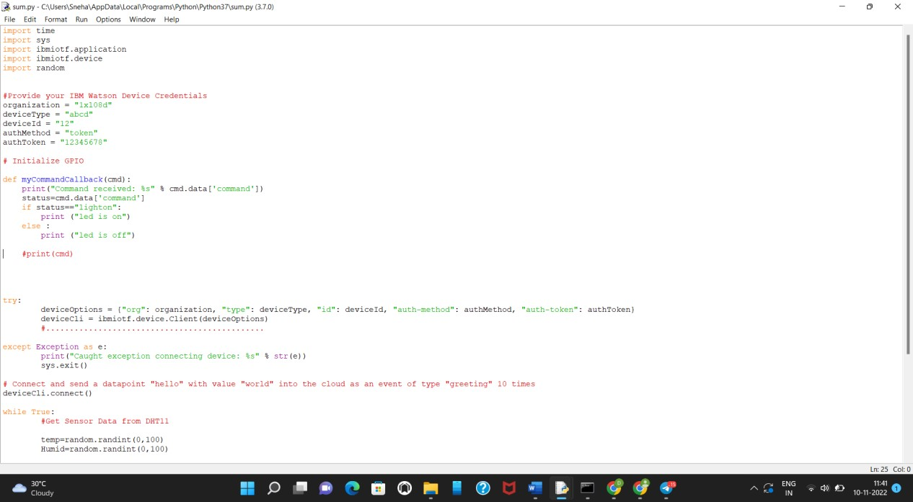

Output

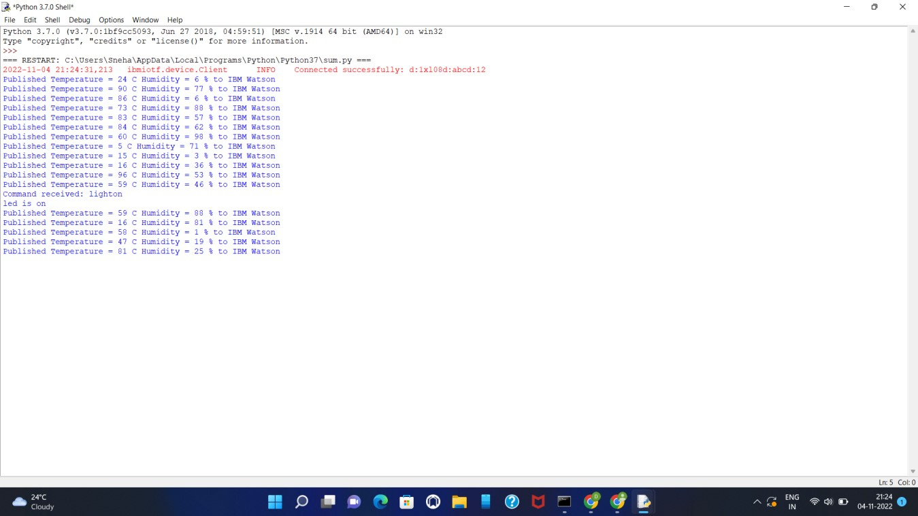

Web APP UI

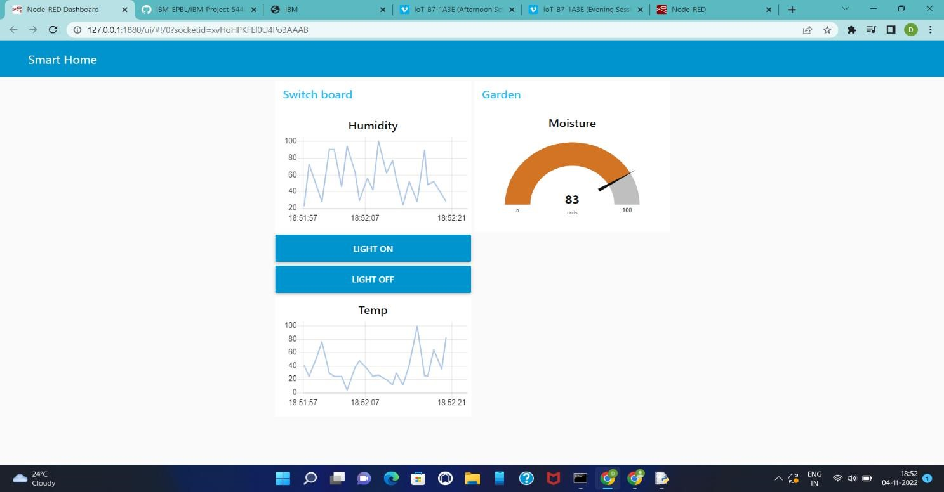

Mobile APP UI:

